**User Manual**

**Account Credentials**

**`**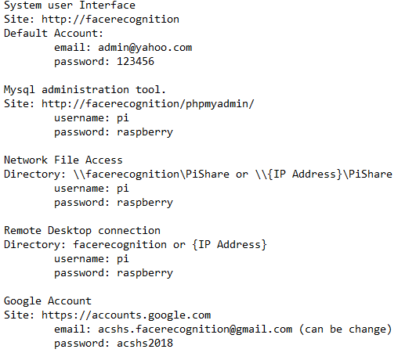

**DEVICE SETUP**

1. Mount the device on the tripod or anywhere
2. Connect UTP cable to the port to gain internet access.

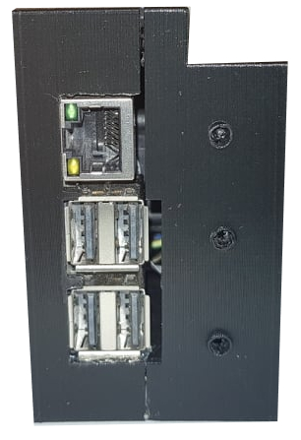

USB PORTS

HDMI PORTS

LAN PORT

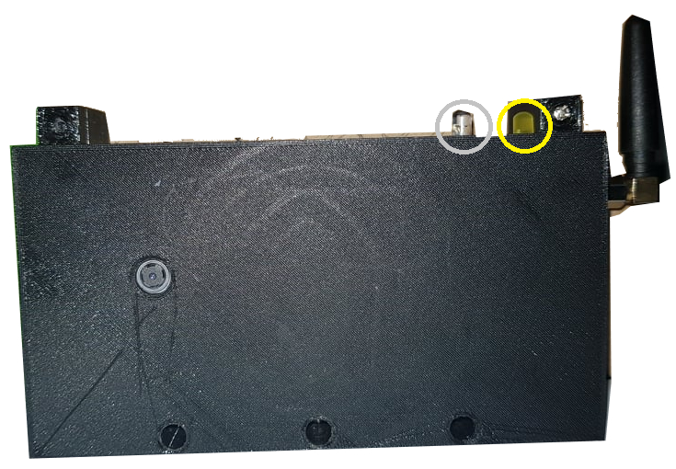

WIRELESS GSM GPRS MODULE

LED INDICATORS

STEREO OUTPUT

MICRO USB POWER SOURCE

CAMERA

1. Connect the HDMI to a monitor
2. Connect the micro USB power source to the outlet
3. For the LED Status

**LED STATUS**

Blue = running system (also indicate training face in Web User Interface)

*When detecting face;*

Blue and blinking Yellow = processing

Green=success face detection

Red= unknown face detected

**WEB FEATURES**

1. All Students

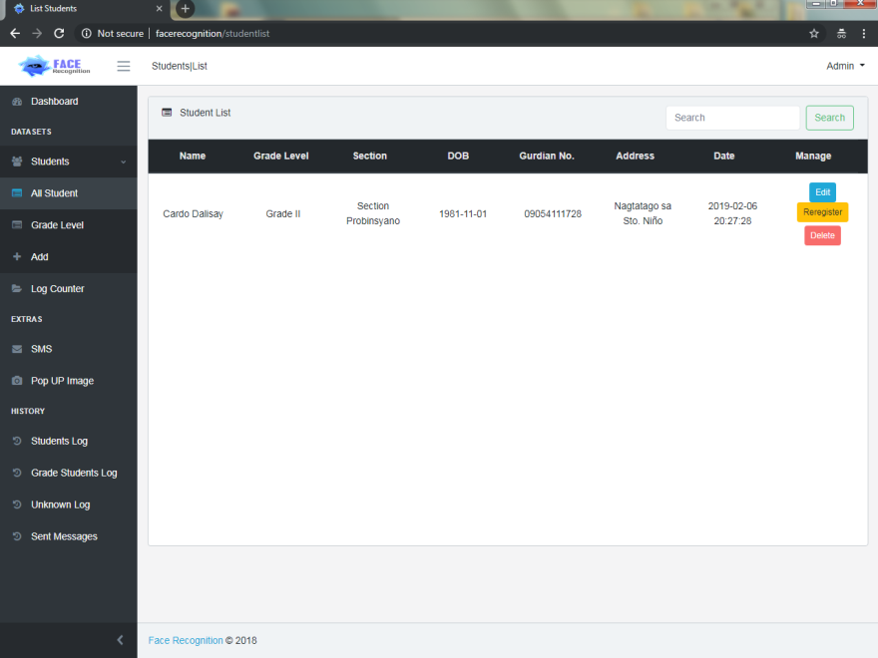

1. Student Profile

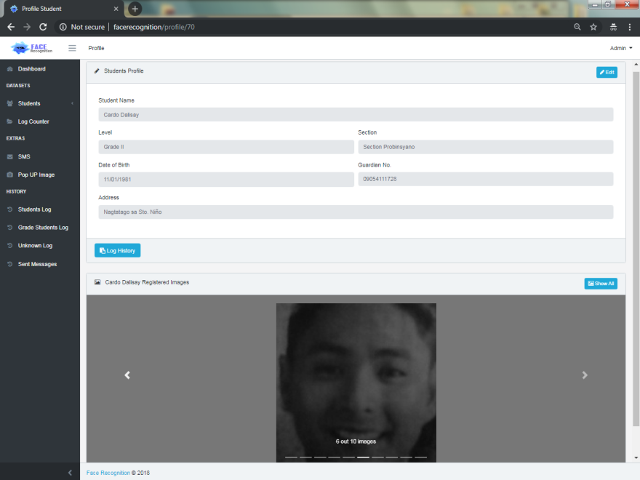

1. Grade Level

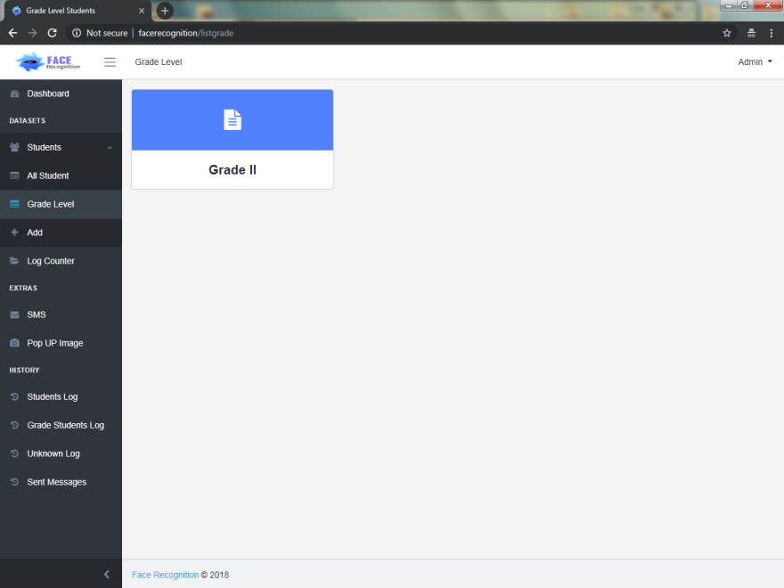

1. Section

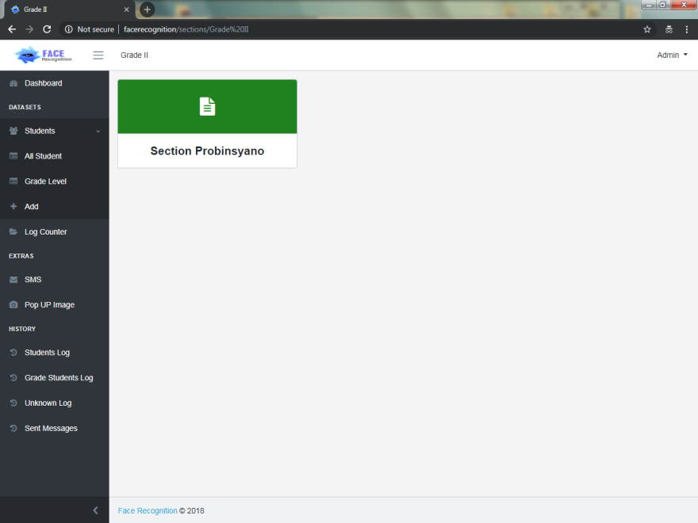

1. Lists inside Section

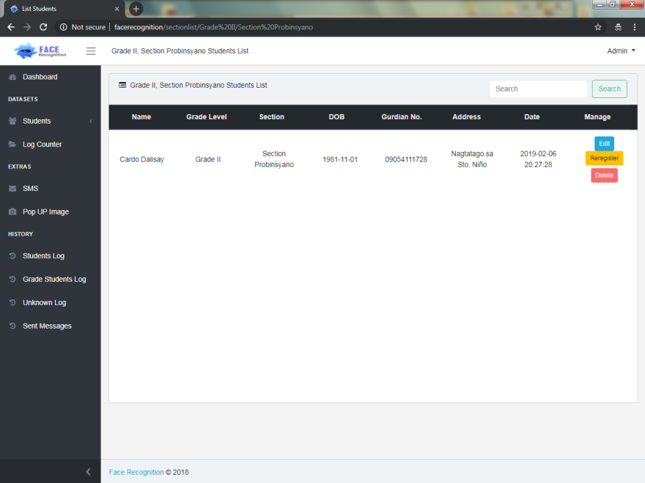

1. Pop out

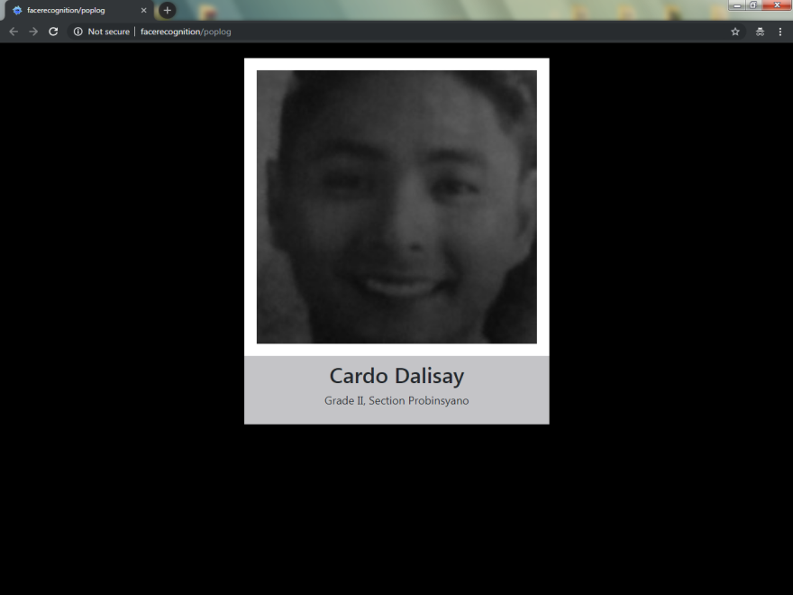

1. Student Logs

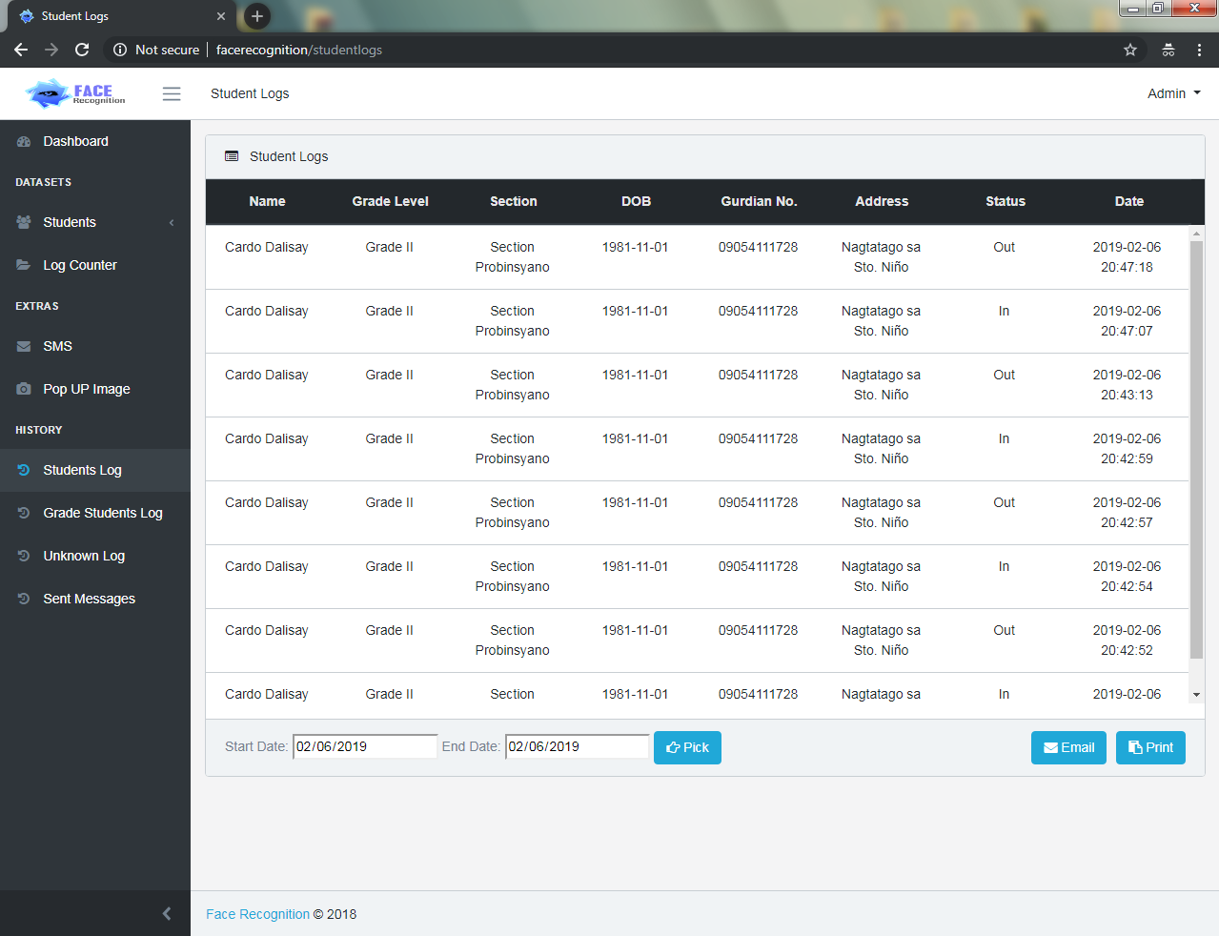

1. Grade Students Log

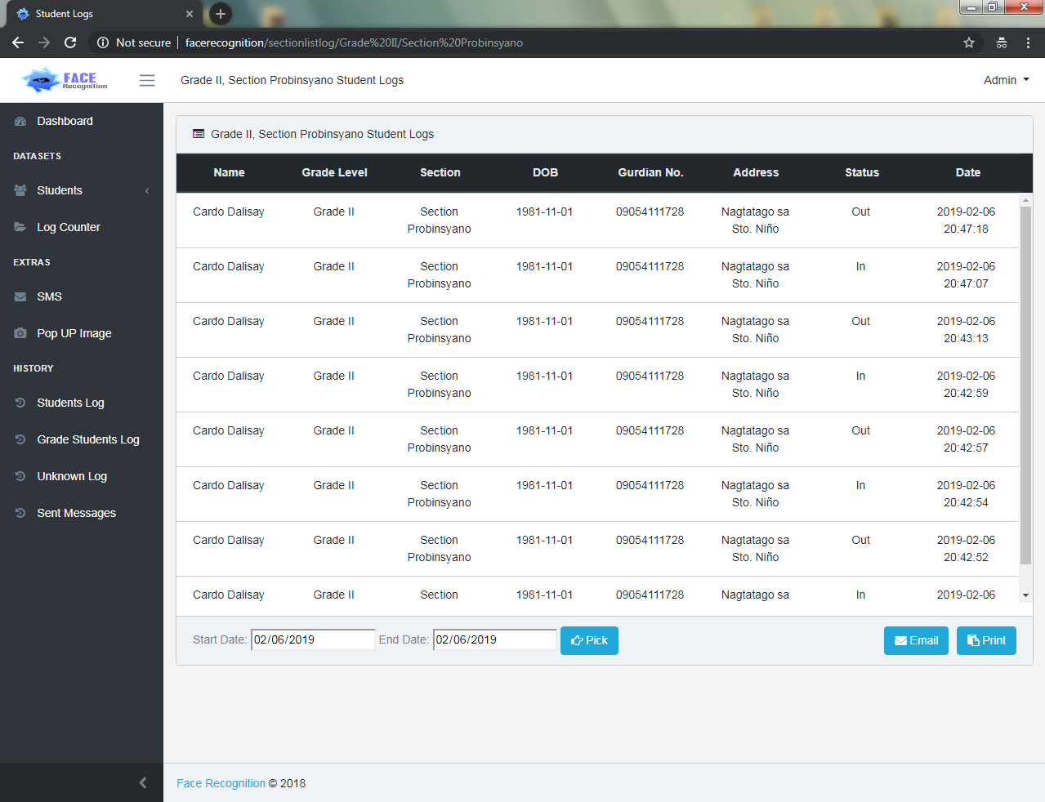

1. Unknown Logs

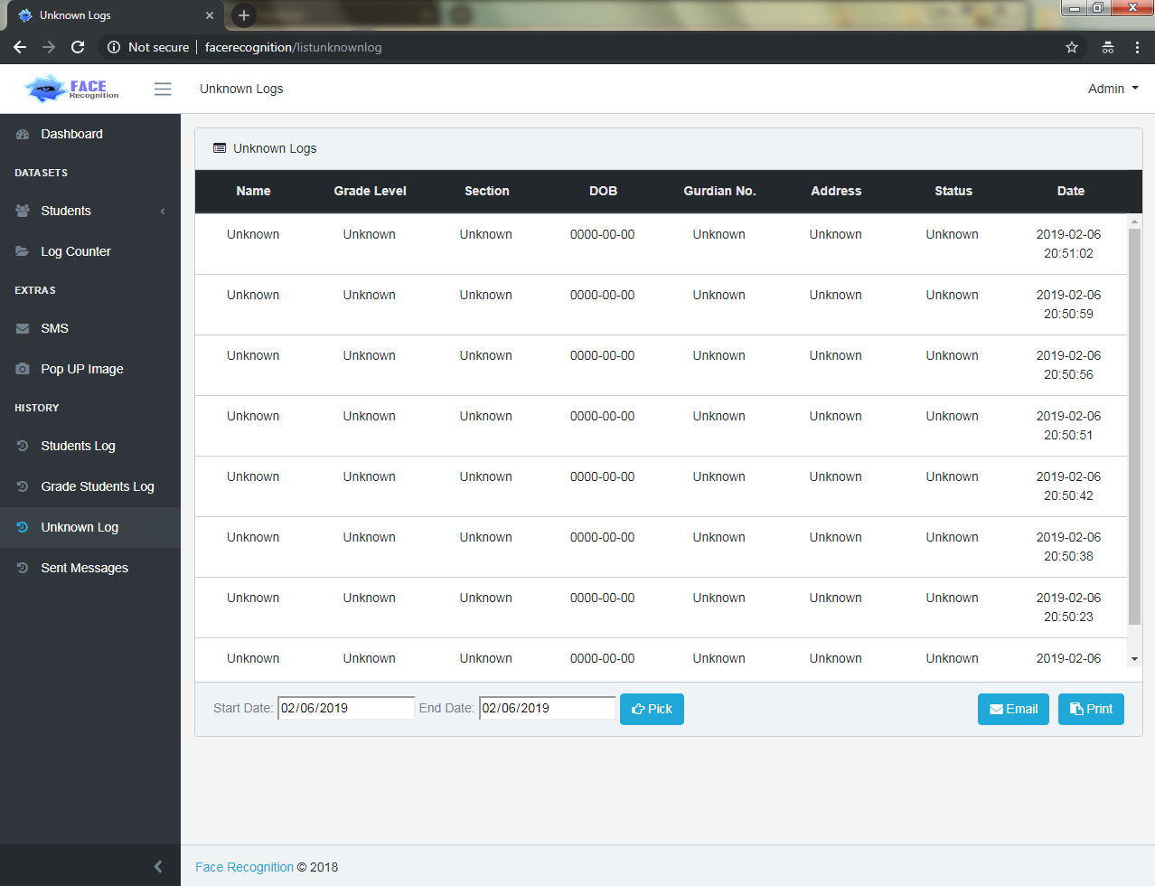

1. Sent Messages Log

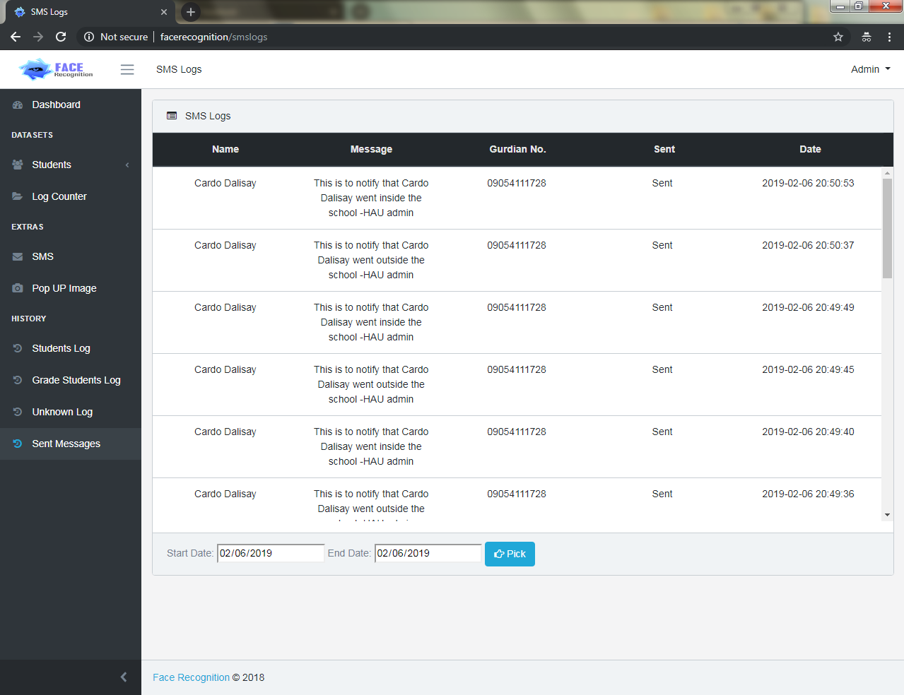

1. Email Logs

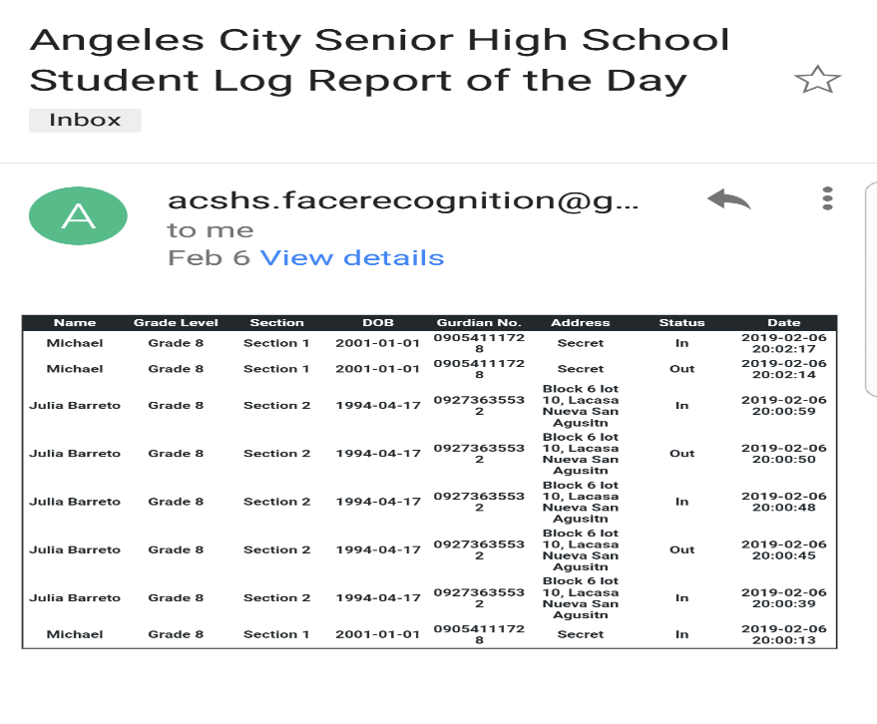

1. Settings

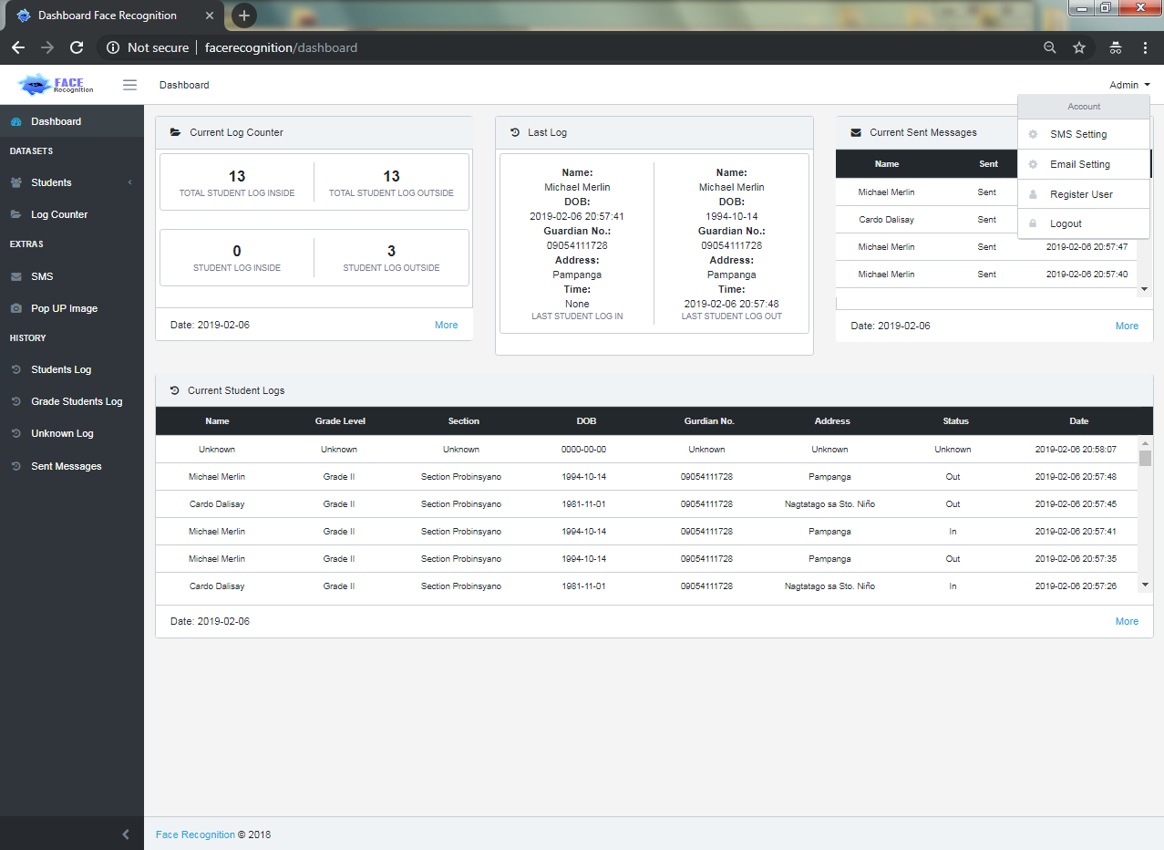

1. SMS Settings

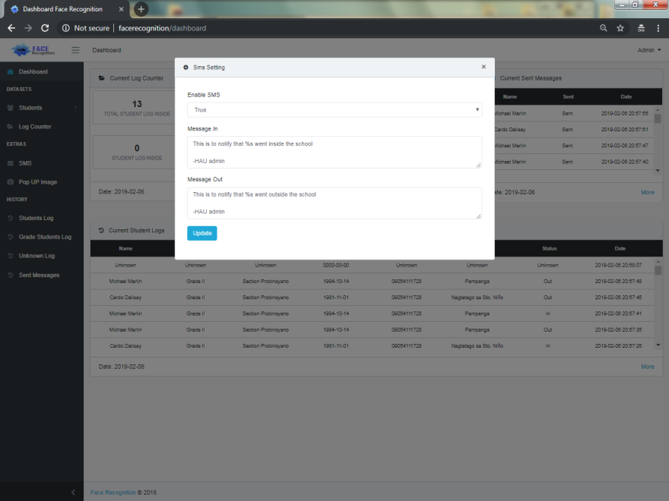

1. New User Account

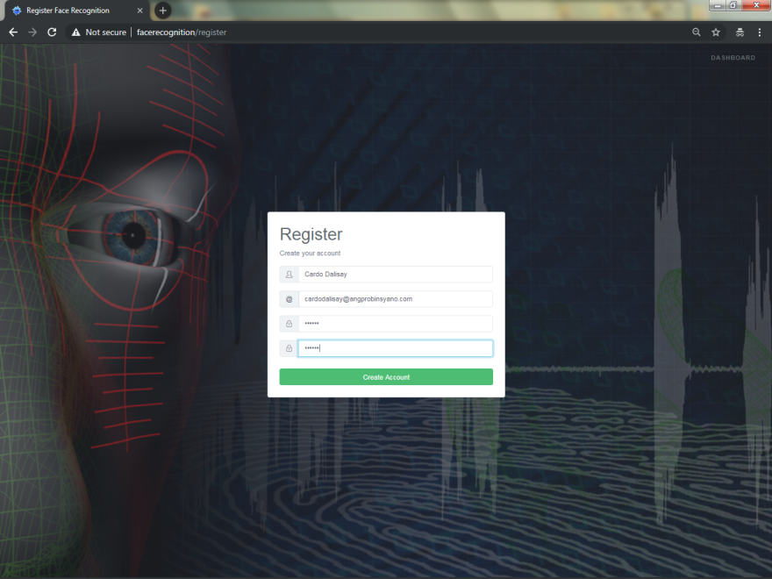

1. Web User Interface Dashboard

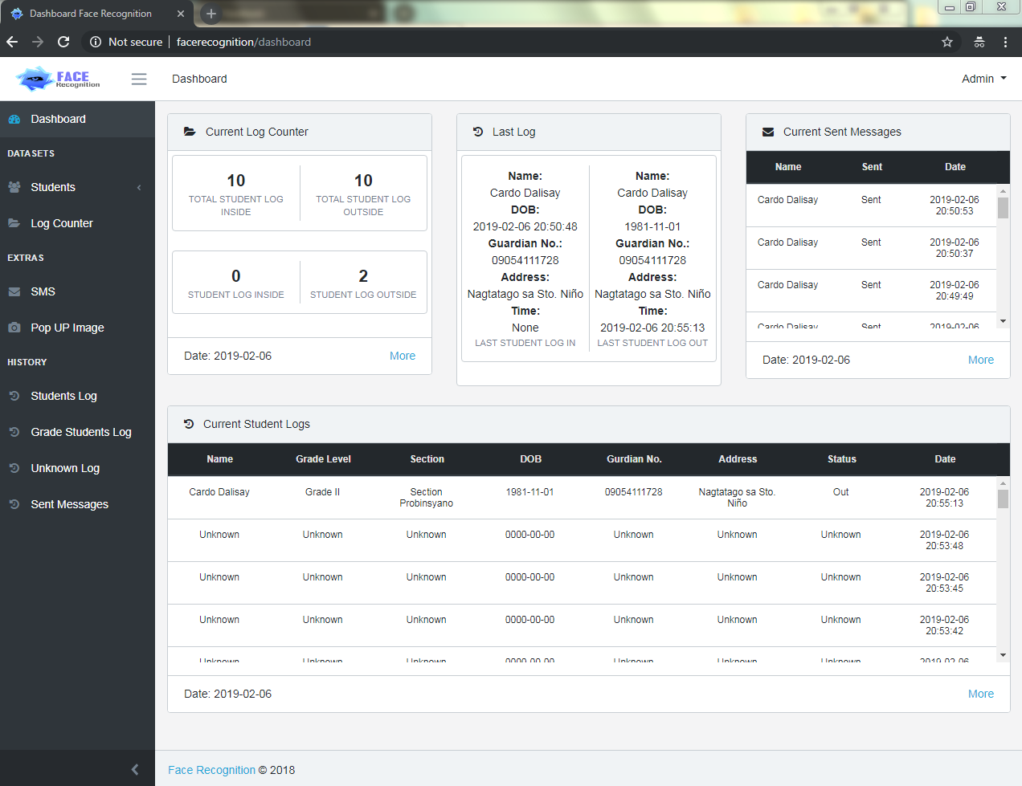

**WEB PROCESS GUIDE**

1. Click Log in

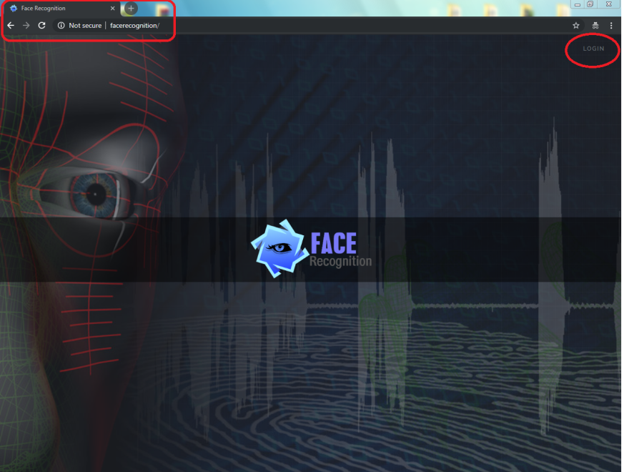

1. Log in Default Admin

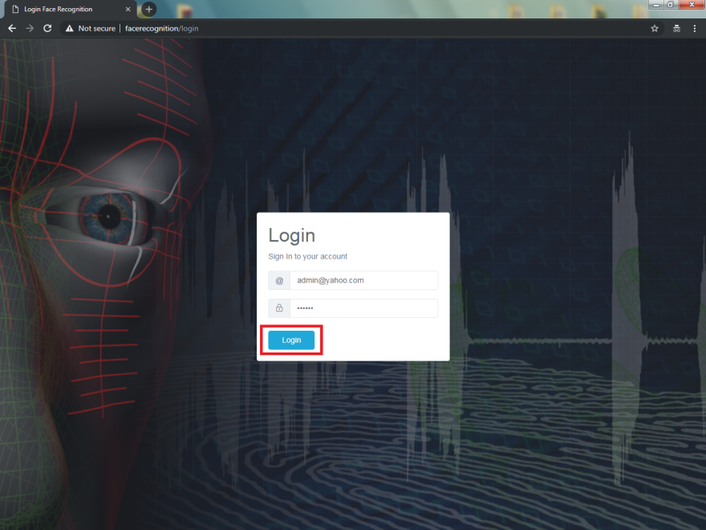

Default Account:

email: [admin@yahoo.com](mailto:admin@yahoo.com)

password: 123456

1. Collapse Student on Dashboard’s Left Panel

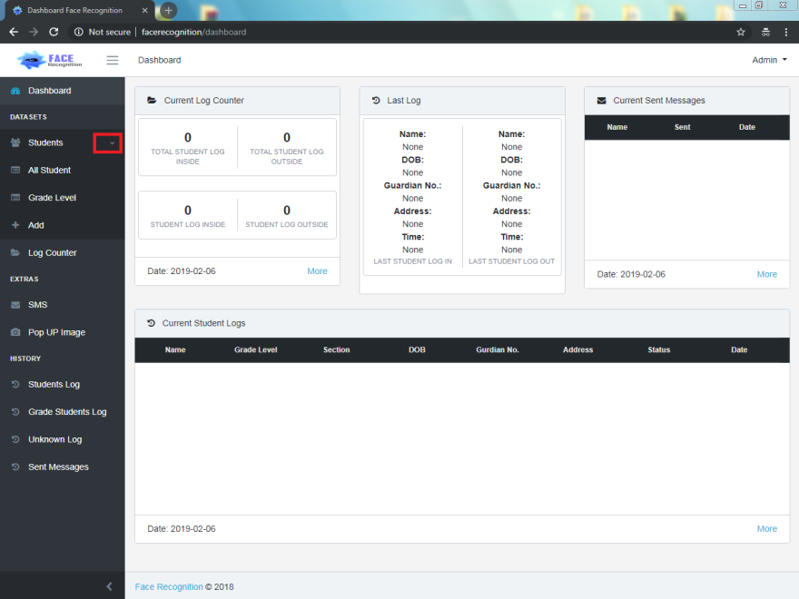

1. Create Profile by clicking Add, then after filling up, click

save

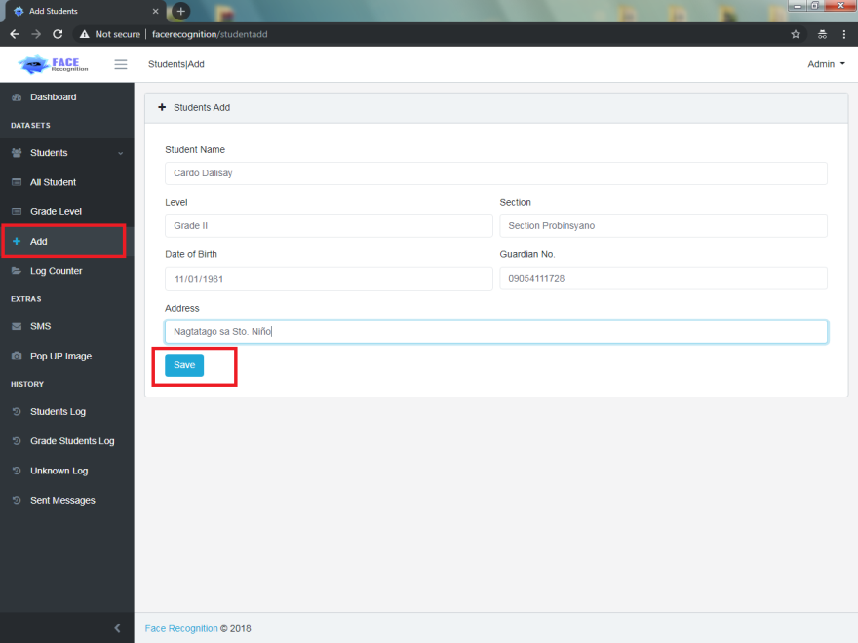

1. Click All student on left panel then Click the Register

Button

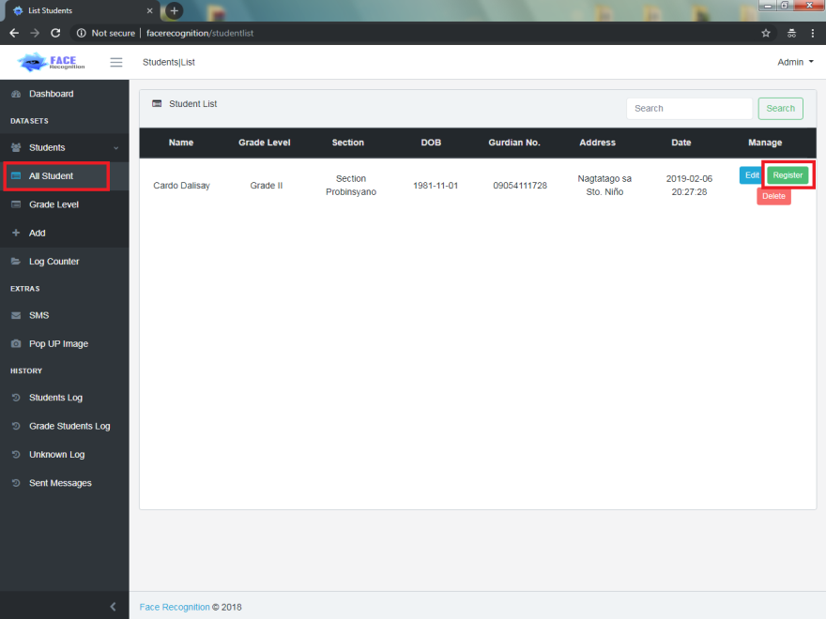

1. Double Click fr.sh then Execute in Terminal (Run it first before registration of profiles in Web User Interface to avoid trouble)

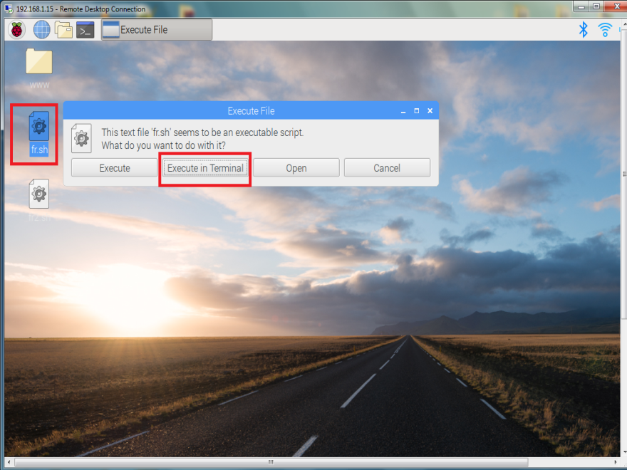

1. Train Face by facing at the camera of the device

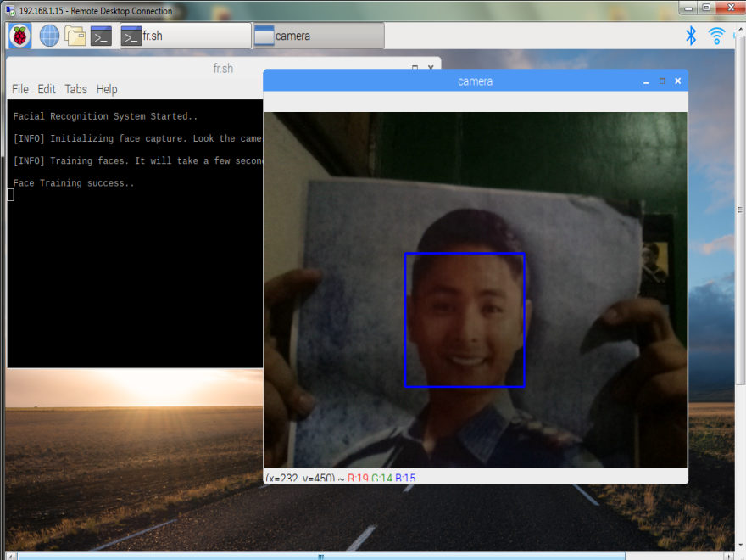

1. Confirm the captured images

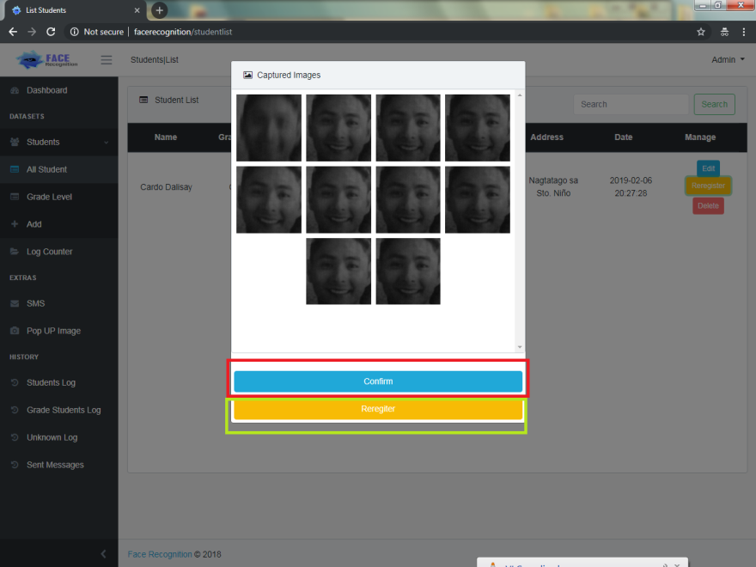

1. Test the registered facial images.

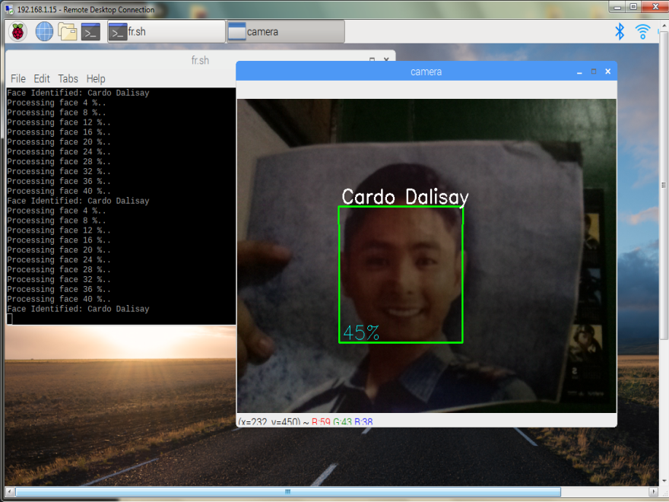

The name of the student will appear when the facial recognition was success.

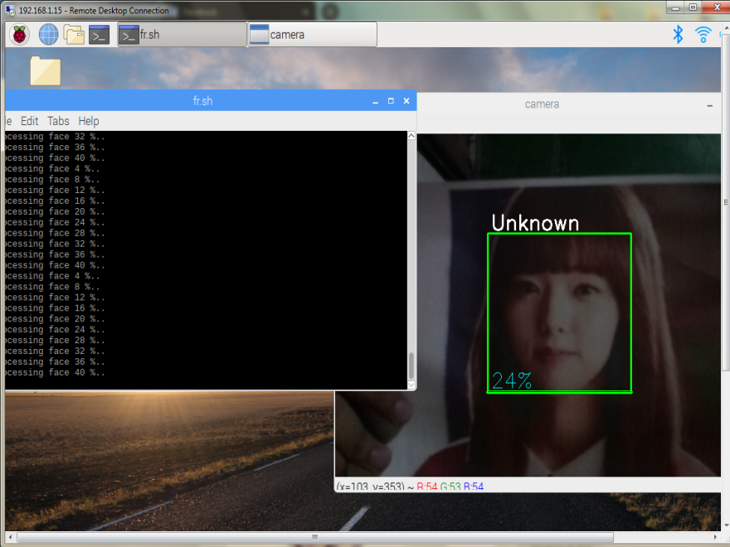

The facial recognition will be unsuccessful if “Unknown” appears.

**Web User Interface and Device Troubleshoot FAQs:**

**Q:What if I registered a profile and train a face via Web User Interface without running the Face Recognition Script File on my Desktop?**

**A:** Before doing the registration and training, make sure to run the script (fr.sh) first to avoid getting stuck on “training processing” at the web. If the user got stuck, kindly run the script and show the face of the user at the camera to continue the processing. Same as re-registering.

**Q:What to do when the device stuck at “beep” sound after I closed the script and cannot closed or terminate the script from running?**

**A:** Run the script again and do not show a face in the camera when closing it again. When the user cannot closed or terminate the script from running via click of “X” button. At the top bar with Raspberry Pi Logo on your Pi desktop. Find and Go to “Task Manager” to terminate the script process.

**Q: What is the problem when the SMS feature of the device is not working?**

**A:** Remove the GSM Module Antenna and put it back again. Another way is open the shield case and find the GSM antenna cable connected to GSM Module SIM800 board, kindly remove and attach it again.

**Q: What is the problem when I cannot receive the email logs from the sender?**

**A:** Check if the internet is off and turn on your internet connection. Another scenario if the sender email account has security alert enabled. Disabling the security alert and plug in and out the utp cable will solve the problem.

**Maintenance Database Management**

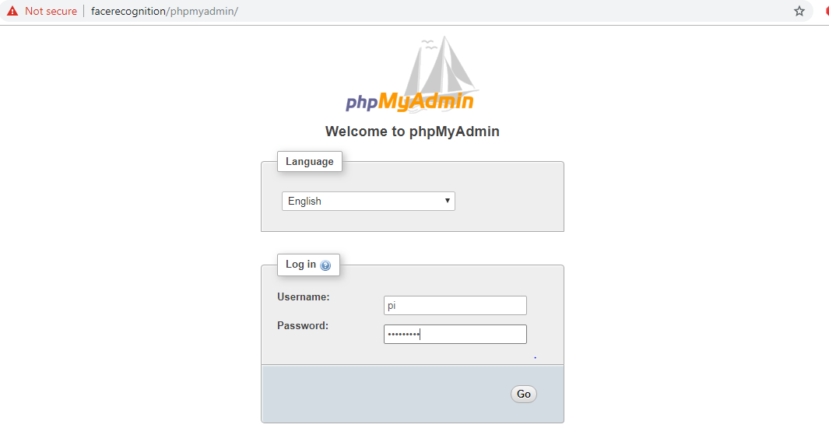

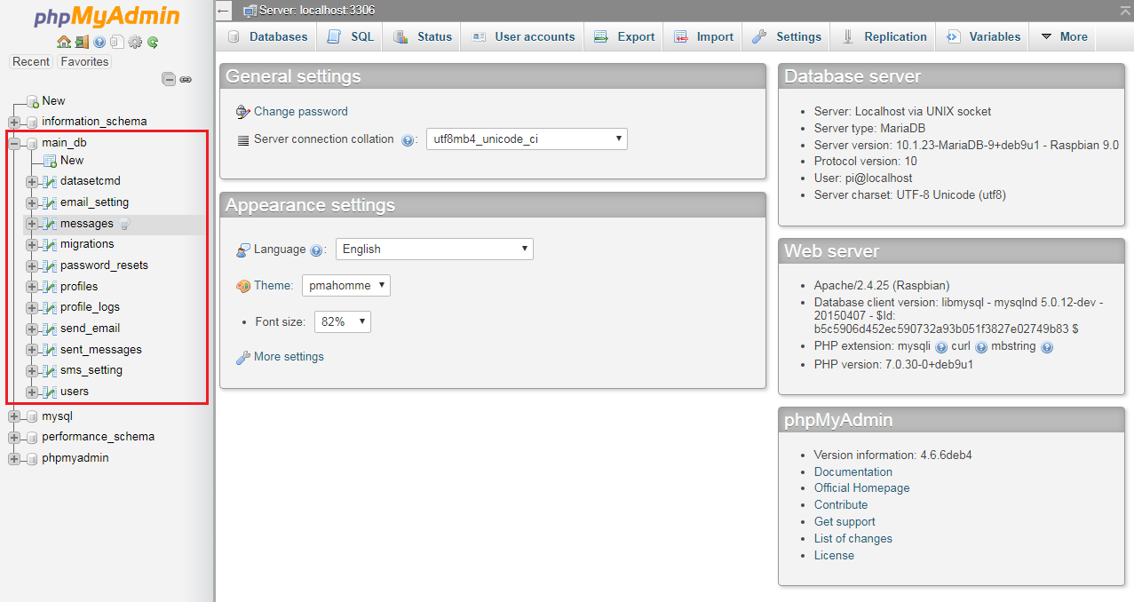

The IoT Device is integrated with the Web User Interface and phpmyAdmin Database Management. The database manages the users, profiles, messages, migration, password resets, profile logs, sent messages logs, dataset, send email, email setting, and sms setting. The maintenance is used only when the administrator decided to delete account user, profiles and clearing logs, wrong inputs and spam from the web user interface. The instructions to clear and delete account user, profile and logs from integrated Web UI and Database are shown below:

**Illustrations:**

Delete and Clear Student Profiles

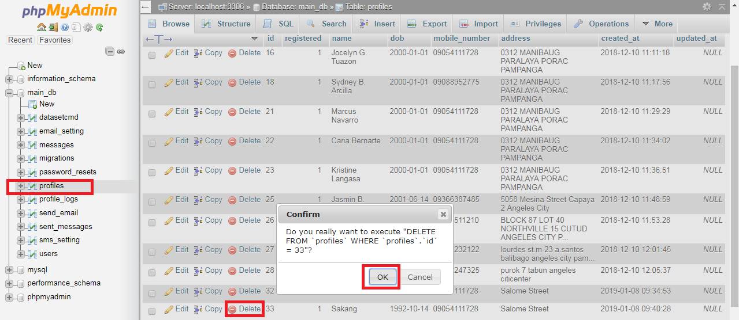

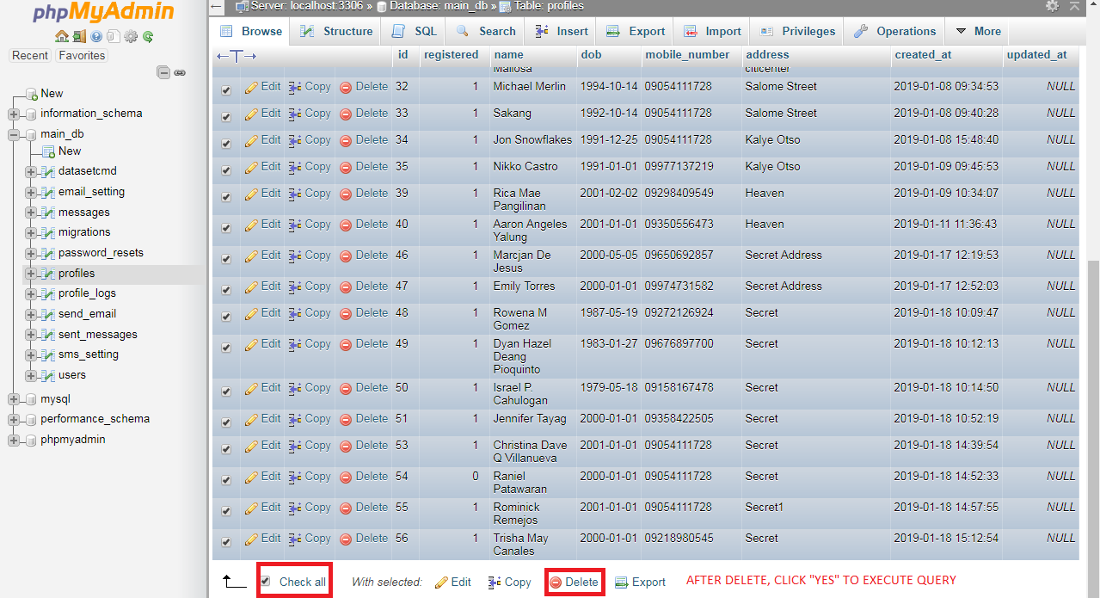

Delete and Clear Student Logs

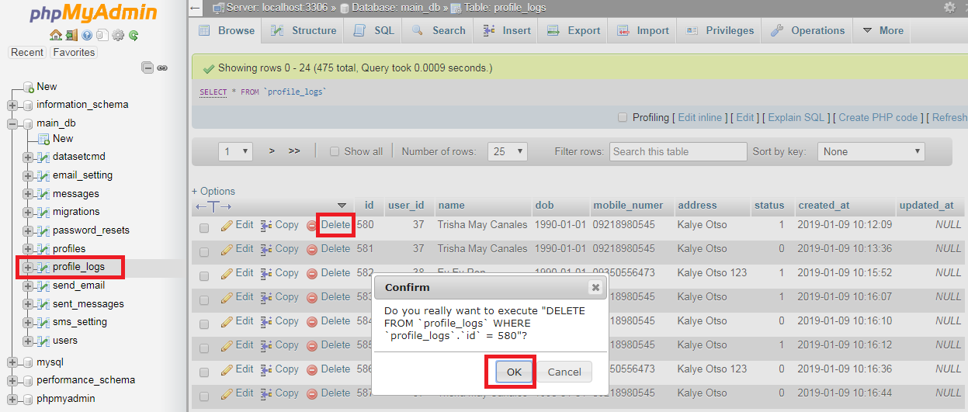

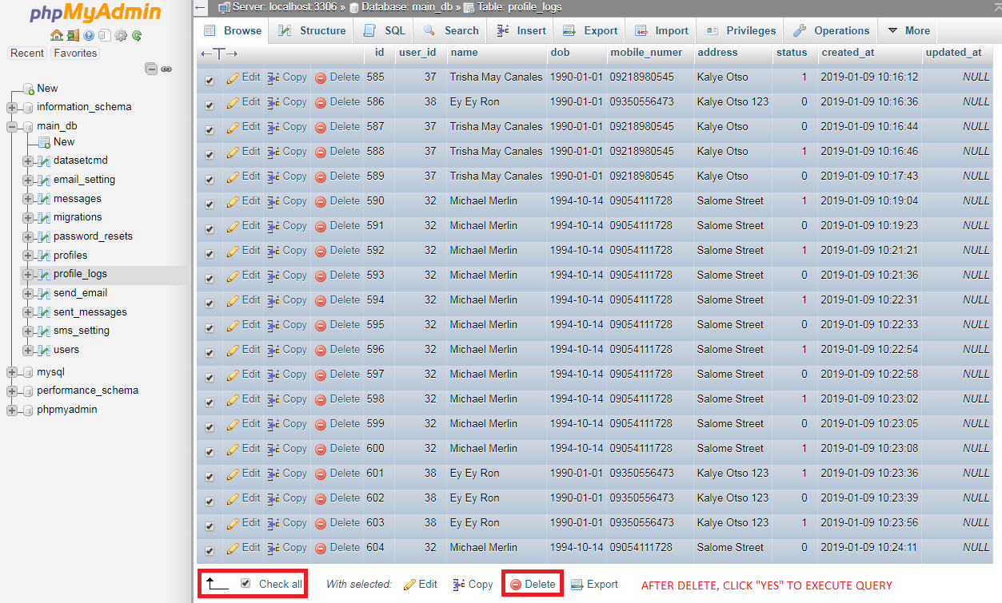Delete and ClearSMS Logs

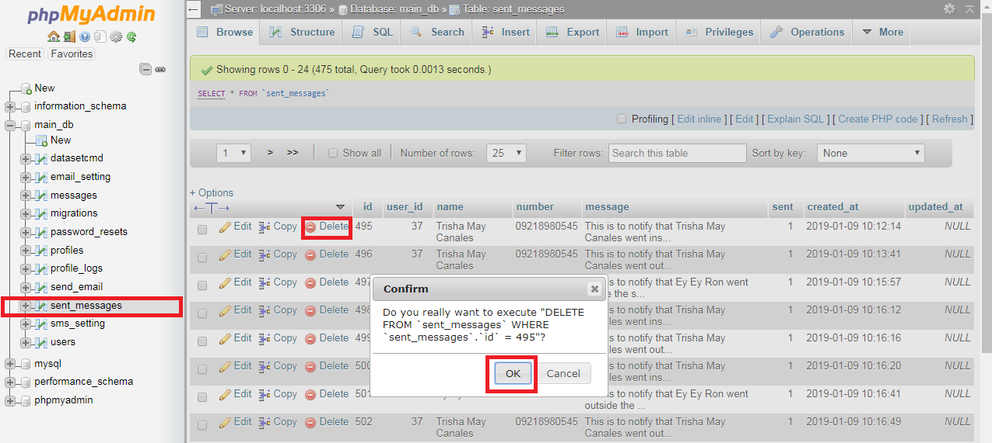

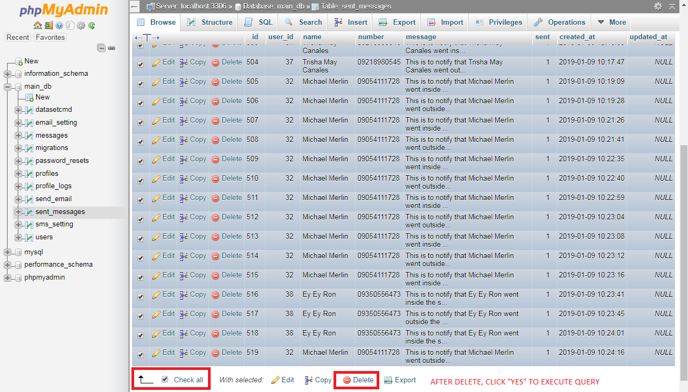

Delete and ClearAdministration Account User

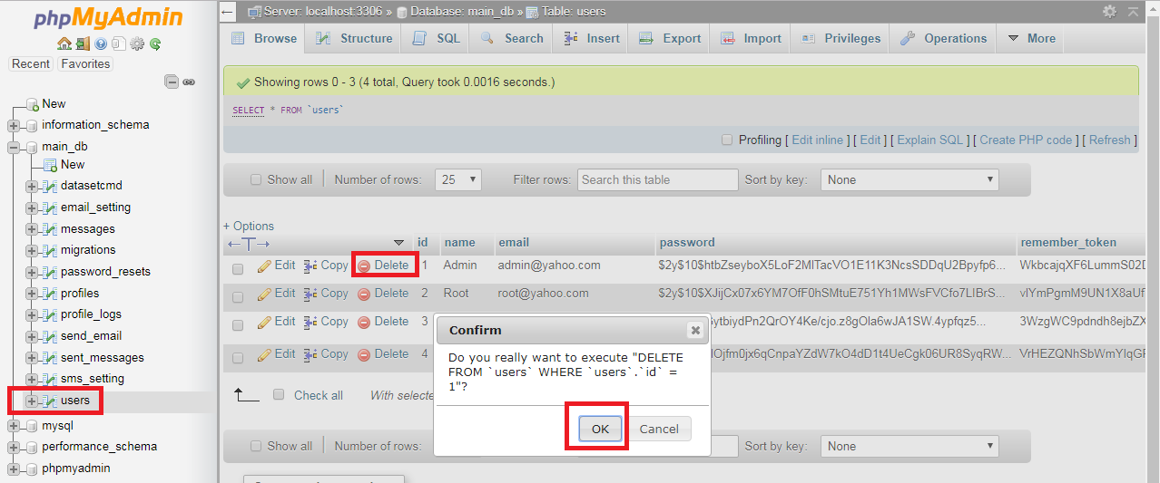

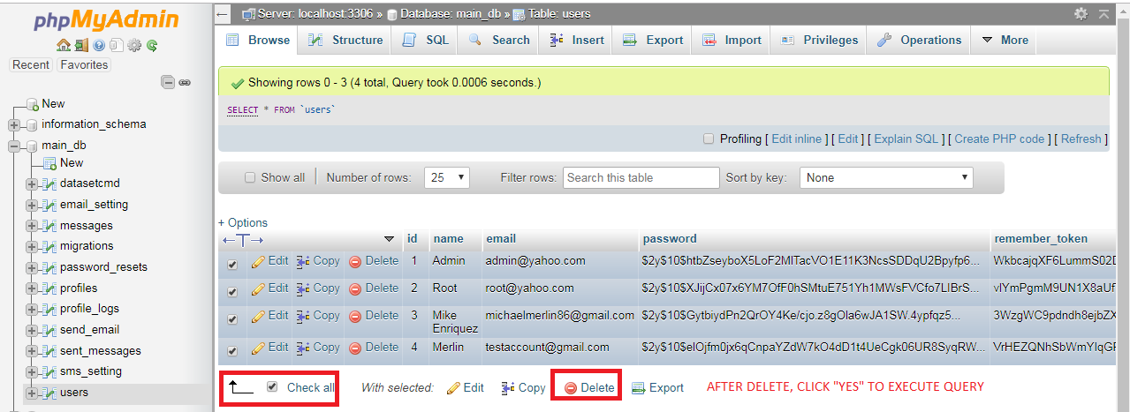

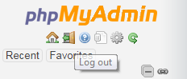

**Notes:**

1. Login the **Mysql phpmyAdmin Account**.

Username: pi Password: raspberry

1. **Database Link Address:**http://facerecognition/phpmyadmin/
2. Collapse the **"main_db"** at the left pane to show each label.